

QUEENSWAY APARTMENT DEVELOPMENT

Queensway Apartments Flat 1 User Manual

Client: City Renovations
Date: 01/02/2017

Contents

Section | Description | Page
Section 1 | Introduction | 2
Section 2 | Building Services Information | 3
2.1 | Electrical Distribution Boards | 3
2.2 | Boiler Controls | 4
2.3 | Thermostat | 7
Section 3 | Valve Schedule | 8
Section 4 | General Information | 9

1.Introduction
Site Address:

Flat 1,
Queensway House, Bletchley
Milton Keynes, MK2 2EE

The purpose of this manual, is to inform the occupant of the apartment, how to use certain equipment within the home.
It will inform you on how best to operate the following equipment:
- Distribution Board
- Boiler
- Thermostat
This manual will also have a small valve schedule for the domestic services, so if at any time you needed to shut-off the water or gas, you know which valve is which.
Finally, there will be a small section on general information about the apartment.

2.Building Services Information

2.1 The distribution board installed in the apartment is a MK7666SMET. If for any reason you need to switch the power to the apartment off, you will need flip the main switch (Highlighted on below image) which will switch off all electrical equipment in the apartment.

If you are looking to turn off individual electrical equipment eg. Kitchen Sockets, then you would flip the switch that corresponds to the kitchen sockets (Which will be noted on the board itself).

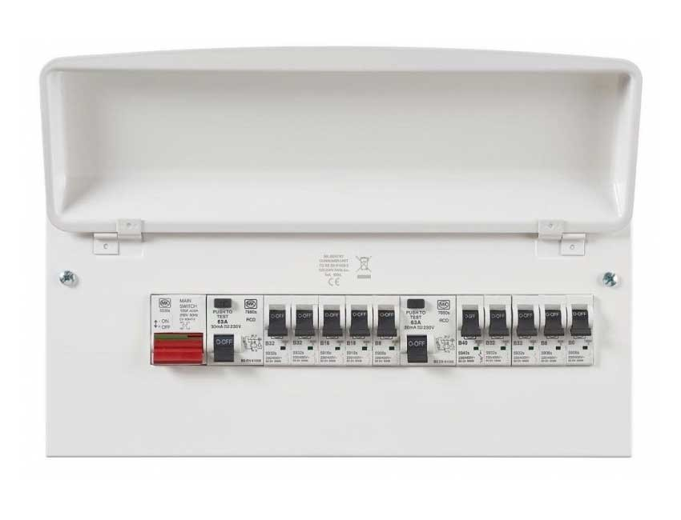

2.2 The boiler installed in the apartment is a Glow-worm Betacom 3 25c. Below are the boiler controls you will need to know.

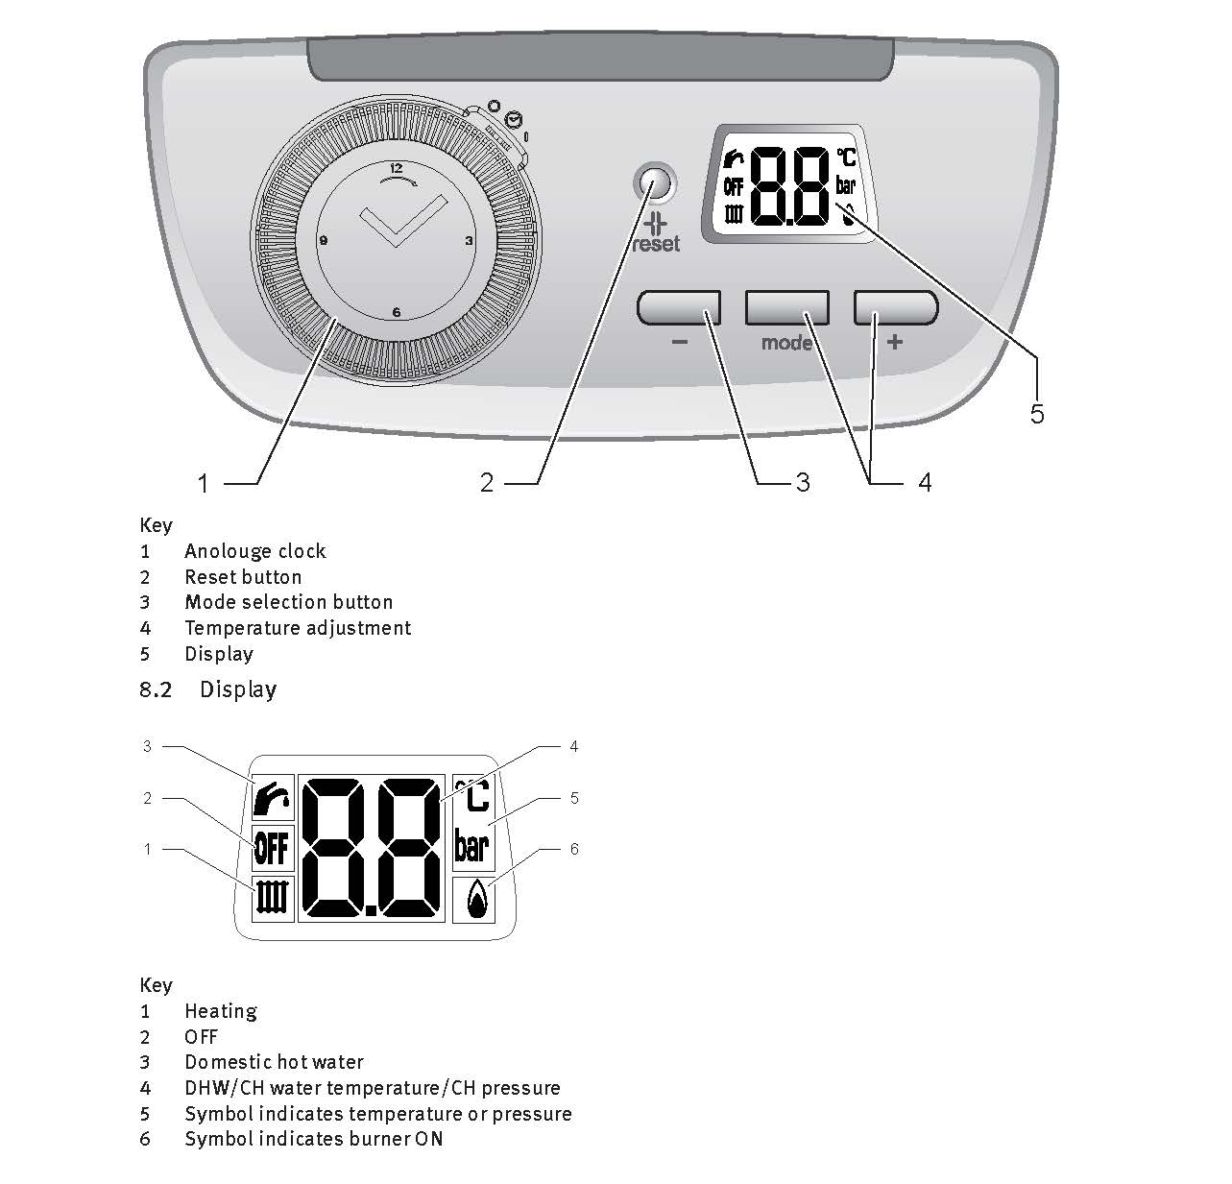

NOTE: INFORMATION ON HOW TO RE-FILL THE PRESSURE IS BELOW
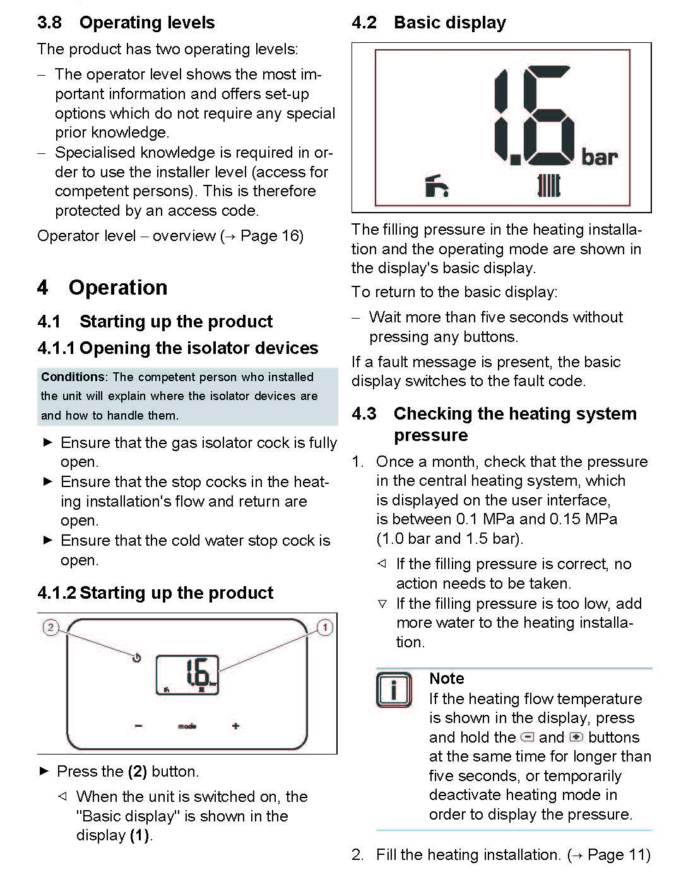

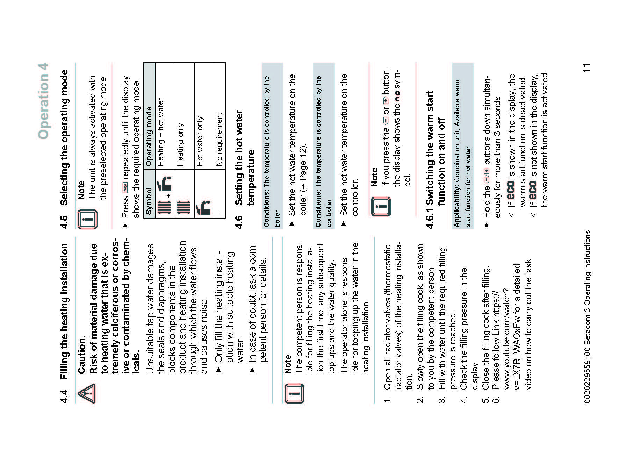
2.3 The Thermostat that has been installed in the apartment is a ESI ESRTP4. Below are the instructions for how to operate the thermostat within the apartment.
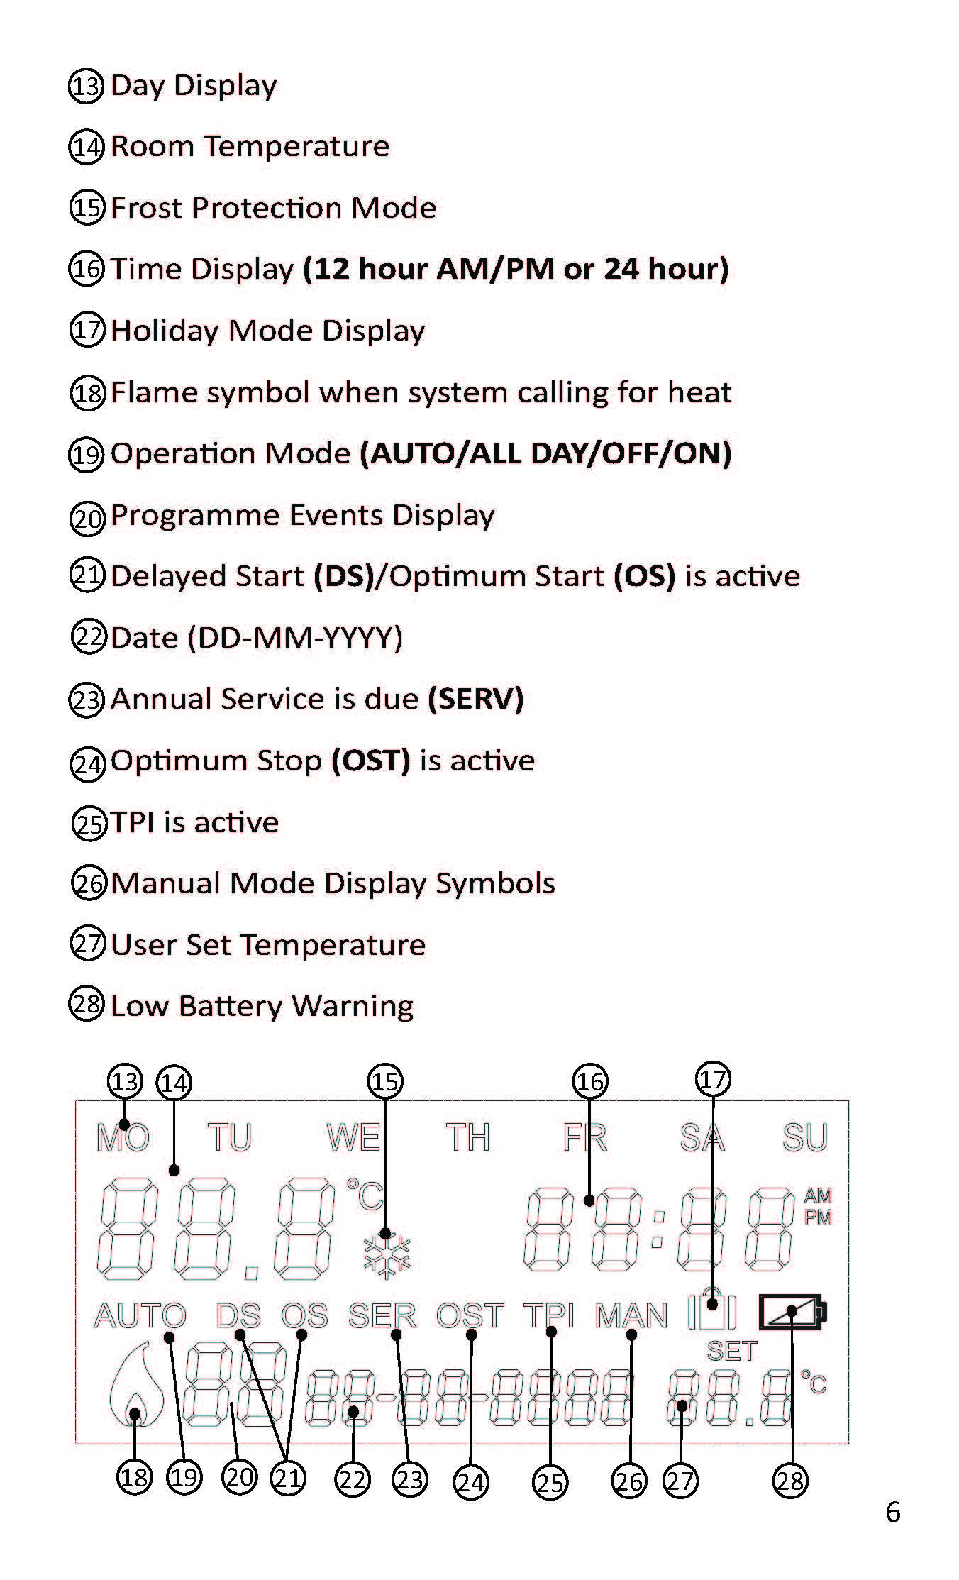
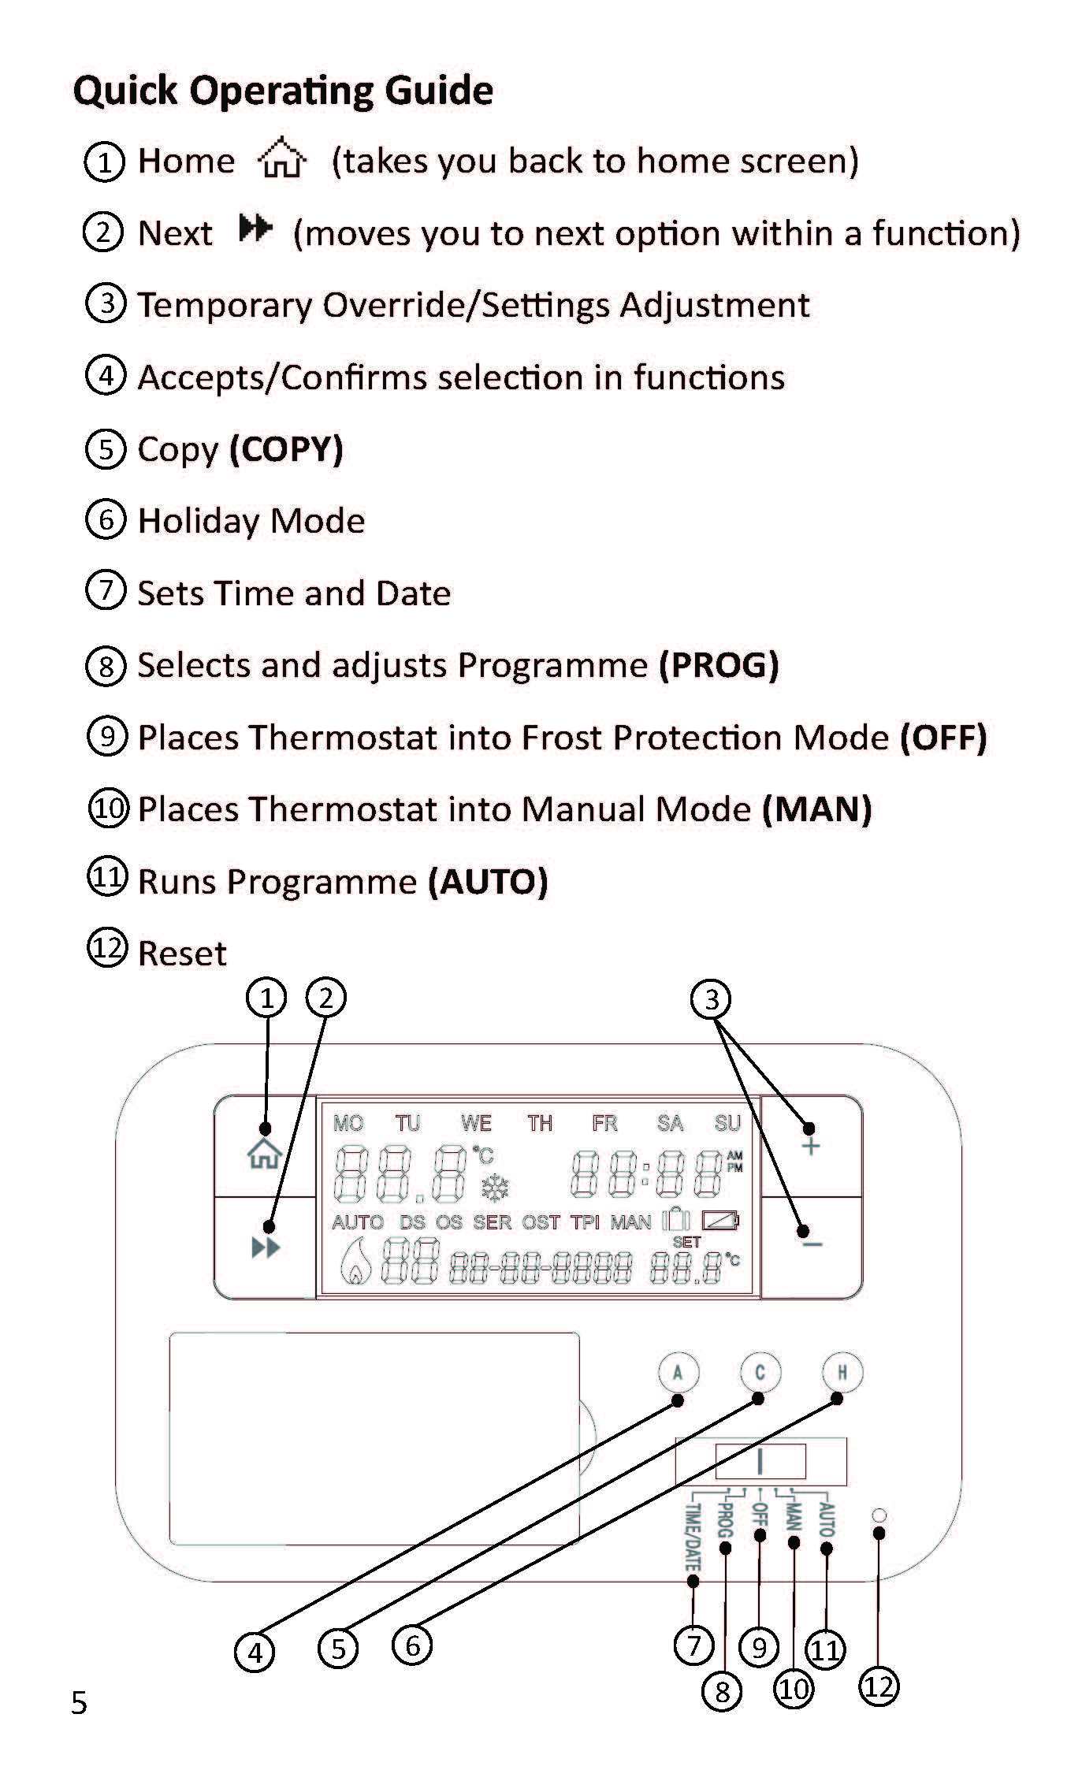
3.Valve Schedule
The valves for the apartment are tagged to represent which system the valve is for. Below are the colored tags and which system the color represents:

- Yellow Tag = Gas

- Blue Tag = Water

4.General Information
- The lamps in the downlights, which are the lights in the kitchen, are GU10 LED Lamps, so if one of the bulbs is to go out, please replace the light with the correct type of bulb.
- The lamps in the pendant fittings are standard Halogen type bulbs.
- The main Telephone point for the apartment is located in the Living/Dining Room.
- The Thermostat is located by the Front entrance.

